**HACCP/Food Safety Plan (Draft)**

**Parts:**

1. Company Overview
2. Scope
3. Flow Diagram
4. Process Narrative (Steps)
5. Hazard Analysis (HACCP)
6. Process Preventive Controls
7. Food Allergen Preventive Controls
8. Sanitation Preventive Controls
9. Supply-chain-applied Preventive Controls Program
10. Validation

**Features:**

* Flow Diagrams
  + Workflows, schematics
  + User interaction (possibly drag and drop)
* Process Steps
  + Data: [step, description, date?]
  + Add, edit, remove
  + Fixed? Internal or global?
  + 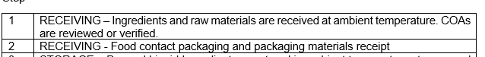
* Hazards
  + Could be a stand-alone data or under a Process Step
  + Categories: **(add Allergens to the list)** 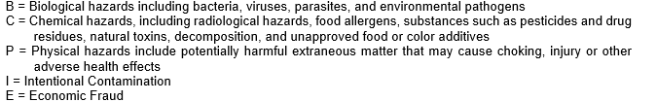
  + 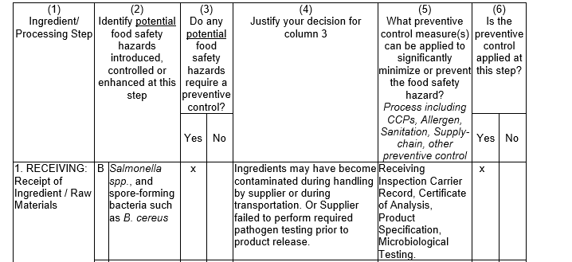
  + *(current evaluation)*
* Plans
  + To be discussed